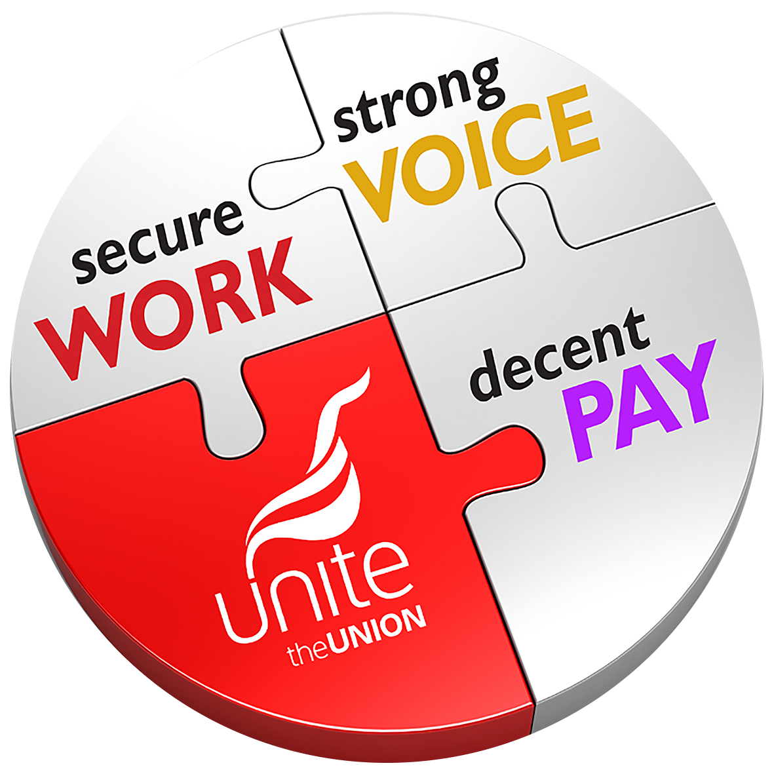
1. My pay is (please tick one): Fantastic  Good  Could be better  Bad 
2. Have you ever found it hard to make ends meet? Yes  No 
3. Please rank the following issues from one to five (1 being most important, 5 being least important):
- Inflation + pay rise 
- More holiday 
- Better night shift payment 
- Improvement to sick pay 
- Improved canteen facilities 
4. Do you think our union reps should have more time granted by the company to campaign for you? Yes  No 
5. Is it important for you to see more temps made permanent? Yes  No 
6. Is there anything else you would like to see included in this year’s pay claim?
…………………………………………………………………………………………………………………………..
5. I am a member of Unite? Yes  No 
6. I want to get more involved with my union at Company X? Yes  No 
Name ………………………………………… Shift ……………………………………………….
Mobile ………………………………………… Email ……………………………………………….
Please keep me in touch about Unite the Union & this campaign by phone  email 
Our Union at Company X
PAY SURVEY 2024

This survey and your personal details will be kept confidential by Unite the Union. The results will be submitted to [company] only and will be retained by Unite for the duration of the [name of campaign] campaign and associated issues. Unite the Union’s full up-to-date privacy policy can be found at www.unitetheunion.org/privacypolicy

Unite is our union at Company X. We are running a pay survey and want to know what your main concerns are for our 2024 pay claim. Please take the time to give us your views. This will be treated in strict confidence and not seen by management.

