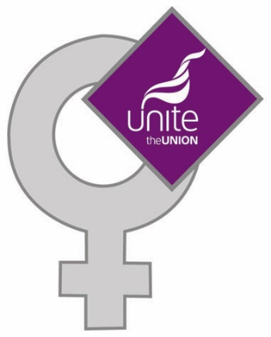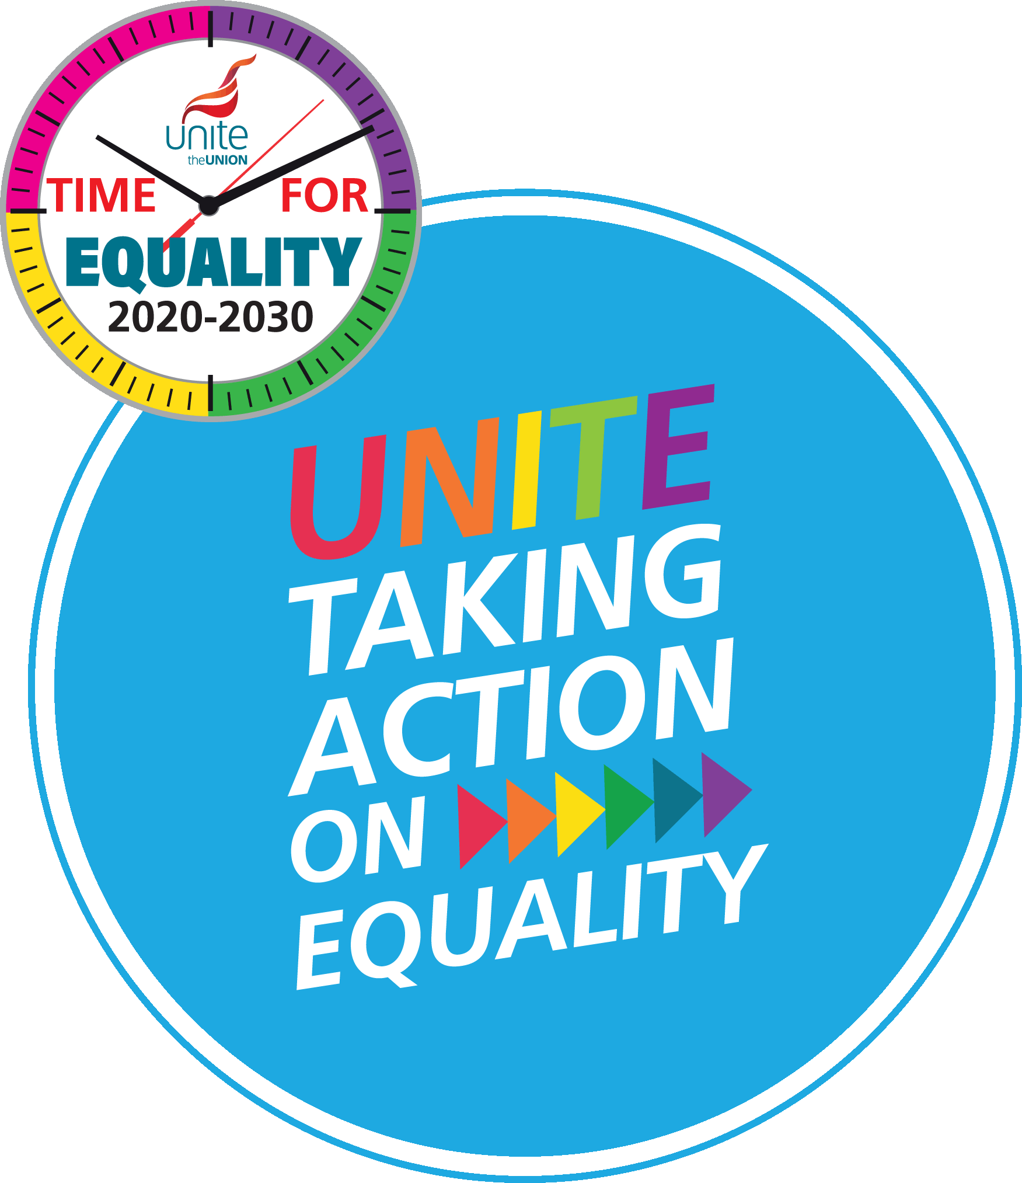

**MENOPAUSE**

**MODEL AGREEMENT**

**MODEL AGREEMENT CHECKLIST**

**and**

**RISK ASSESSMENT CHECKLIST**

**UNITE THE UNION**

[www.unitetheunion.org/equalities](http://www.unitetheunion.org/equalities)

**Unite Model Agreement - The Menopause**

This model agreement outlines key areas for negotiating improved rights for women going through the menopause in the workplace. As with any other model agreement, it should be adapted to reflect the priorities and concerns in each workplace before it is presented to the employer.

**1. Introduction**

**1.1** The employer and the union recognise that the menopause is a key issue for women in the workplace particularly with regard to:

* Enhancing the equal opportunities of women at work.
* Ensuring women’s health, safety and welfare whilst at work.
* Recognising the talent and contribution of all sections of its workforce.
* Ensuring that the employer recruits and retains skilled workers.

**2. Scope**

This agreement will apply to all employees irrespective of grade, status, sex, race, nationality, disability, sexual orientation, age, caring responsibilities, gender identity, hours worked and length of service.

**2.1** The employer and the union recognise that health, safety and welfare, sex discrimination, disability discrimination and equal pay for work of equal value are subject to provisions laid down in legislation.

**2.2** The employer and union undertake to monitor and review this agreement on a regular basis to ensure that, as a minimum, it meets the requirements of the law.

**2.3** The employer and the union agree that individual grievances shall be subject to the existing grievance procedure.

**3. Equal opportunities**

**3.1** The employer opposes all forms of discrimination directly or indirectly related to the menopause, including on the grounds of age, sex, race, disability, sexual orientation and gender identity and including discrimination in training, promotion and job security.

**3.2** The employer will remove any additional barriers faced by Black women, disabled women, and Lesbian, Bisexual women and Trans+ employees experiencing the menopause.

**3.3** The employer and the union will work in partnership to promote a positive attitude towards employees throughout the menopause and endeavour to create a working environment where work and the health effects of the menopause on women workers can be combined.

**3.4** The employer offers flexible working as default for all existing and future positions.

**3.5** The employer undertakes to ensure that appropriate training is given to all employees with supervisory and personnel responsibilities to ensure the effective implementation of this equal opportunities commitment.

**3.6** The role of union equality representatives in promoting equality at work is recognised as important and will be supported through paid release and training.

**4. Health, safety and welfare**

**4.1** The employer recognises that the menopause is not an illness

**4.2** The employer also recognises that the menopause is a workplace health, safety and welfare issue for women in particular but safe and healthy working affects all employees.

**4.3** In accordance with the Health and Safety at Work Act 1974 and other legislation and regulations, the employer is committed to ensuring that the jobs, the work environment (including the provision of clean, safe and accessible sanitary and welfare facilities and maintaining a comfortable workplace temperature) are designed to be safe for all workers, including menopausal women workers.

**4.4** The employer undertakes to carry out appropriate risk assessments including individual assessments, in line with the Management of Health and Safety at Work Regulations 1999 (as amended) and comply with any other regulations that may apply to a particular work situation – including their duty under the Working Time Regulations 1998 to offer health assessments to night workers.

**4.5** The employer undertakes to consult and involve the union safety representative(s) in all health and safety matters and decisions.

**4.6** It is recognised that some work may be more hazardous for, or endanger the health of, menopausal women and that job adjustments may need to be made to ensure the health, safety and welfare of all the employees. The woman’s right to transfer her duties in these circumstances, including transferring from night shift duties, without loss of pay or status, is recognised.

**4.7** The employer recognises their duty when providing personal protective equipment to take account of the health of those who may wear it and undertakes to provide uniforms and personal protective equipment and clothing which are suitably designed for menopausal women.

**4.8** The employer undertakes to ensure that a flexible approach is adopted towards rotas, shifts and the provision of toilet and rest breaks.

**4.9** The employer recognises that experiences of the menopause may differ greatly for each employee particularly, for trans+ employees.

**4.10** The employer appoints a named person for confidential support and advice for women regarding any issues related to menopause.

**4.11** The employer recognises that providing information and training about the menopause is essential for all managers and supervisors to ensure that menopause issues are handled sensitively and appropriately in the workplace.

**4.12** The employer also recognises that providing information, training and support for all workers is essential, including general health awareness.

**5. Medical treatment and screening**

Menopausal women employees will be entitled to take time off in paid work time to attend medical appointments and screening.

**6. Sickness absence**

**6.1** The employer recognises that the menopause is not an illness and that sickness absence, capability, disciplinary and performance policies will not penalise women who have to take time off from work because of symptoms related to the menopause.

**6.2** Absence for reasons associated with the menopause will be recorded separately and where appropriate as an ongoing, fluctuating health issue.

**6.3** The employer ensures return to work interviews consider that absence could be related to the menopause and train managers to have a supportive and sympathetic approach.

**Menopause Model Agreement Checklist**

|  |  |
| --- | --- |
| **The following should be considered:** | Tick Mark Vector Art, Icons, and Graphics for Free Download |
| Consultation agreements |  |
| Representation agreements |  |
| Risk Assessment – consider your health and safety policy |  |
| Employee advice, information and support - agreements |  |
| Sickness absence |  |
| Paid time off for medical appointments and treatment |  |
| Rest and toilet breaks |  |
| Work environment and adjustments |  |
| Paid time off for medical treatment |  |
| Occupational health screening |  |
| Health promotion, advice and support |  |
| Flexible working patterns and rest breaks |  |
| Avoiding discrimination and unfair treatment |  |
| Training and awareness raising for all including managers and supervisors |  |

**MENOPAUSE RISK ASSESSMENT CHECKLIST**

**1. Health and safety management**

|  |  |
| --- | --- |
| Is there a workplace menopause agreement/policy? |  |
| Have managers and supervisors been trained in issues relating to health, safety and welfare and the menopause including the experiences of BAEM, disabled, LBT+, younger and older employees? |  |
| Have managers and supervisors been trained in issues relating to women’s health, safety and welfare? |  |
| Does the risk assessment include consideration of the menopause and other gender issues? |  |
| Does the risk assessment include consideration of the menopause for trans+ employees? |  |
| Is an individual risk assessment related to the menopause carried out? |  |
| Do workers have access to information on the menopause? |  |
| What occupational health arrangements have been made in relation to the menopause? |  |
| Does the sickness absence policy recognise the menopause as a health, safety and welfare issue? |  |
| Is there flexibility in regards to working hours and practices including temporary or permanent adjustment of shift patterns or hours, home working, alternative tasks and duties? |  |
| Are there arrangements for lone workers and travelling to and from work at unsocial hours? |  |
| Is an environment of openness and transparency encouraged where members can talk about the menopause? |  |
| Can women report menopause related sickness to a woman manager? |  |
| What arrangements are in place to deal with related issues such as stress management? |  |

**2. Sanitary and health issues – frequent urination, heavy periods, irregular periods, nausea and vomiting**

|  |  |
| --- | --- |
| Are workstations easily accessible to safe, clean sanitary and rest facilities? |  |
| Are there private washing and changing facilities? |  |
| Is there access to free sanitary products? |  |
| Do rotas, shifts and schedules ensure that workers have easy access to safe, clean sanitary and washing facilities including for mobile workers and those on off-site or temporary locations? |  |

**3. Temperature - hot flushes and perspiration**

|  |  |
| --- | --- |
| Is there a policy on workplace maximum (and minimum) temperature and is it implemented? |  |
| How is it implemented? |  |
| Is ventilation available and is it regularly maintained? |  |
| Is additional ventilation eg portable fans provided if necessary? |  |
| Do uniforms and PPE reflect the needs of menopausal women? |  |
| Is loose clothing provided? |  |
| Is it made of natural fibres? |  |
| Is there access to cold drinking water including for mobile workers and those on off-site or temporary locations? |  |

**4. Aches and pains, dizziness, lack of energy, headaches**

|  |  |
| --- | --- |
| Have workstation risk assessments been reviewed to take the menopause into account? |  |
| Are there opportunities to switch to lighter or different duties? |  |
| Do manual handling assessments take these issues into account? |  |
| Are sickness absence policies sympathetic? |  |
| Are there flexible working arrangements in place in relation to breaks? |  |
| Do working hours in general take account of these health issues? |  |

**5. Reproductive organs; and bone damage**

|  |  |
| --- | --- |
| Is there access to natural light? |  |
| Are there regular and flexible breaks? |  |
| Are uniforms etc made of natural fibres? |  |
| Are work processes considered? |  |

**6. Mood swings, irritability, loss of concentration, insomnia**

|  |  |
| --- | --- |
| Is there flexible working time? |  |
| Are there flexible breaks? |  |
| Is there access to natural light? |  |

**7. Workstations and work environment: skin and eyes**

|  |  |
| --- | --- |
| Have workstations design been assessed and reviewed? |  |
| Where VDUs are used are there regular breaks? |  |
| Are ventilation systems functioning? |  |
| Are humidifier systems functioning? |  |

**8. Are there any other conditions in your workplace which may be relevant to menopausal women?**

|  |
| --- |
|  |