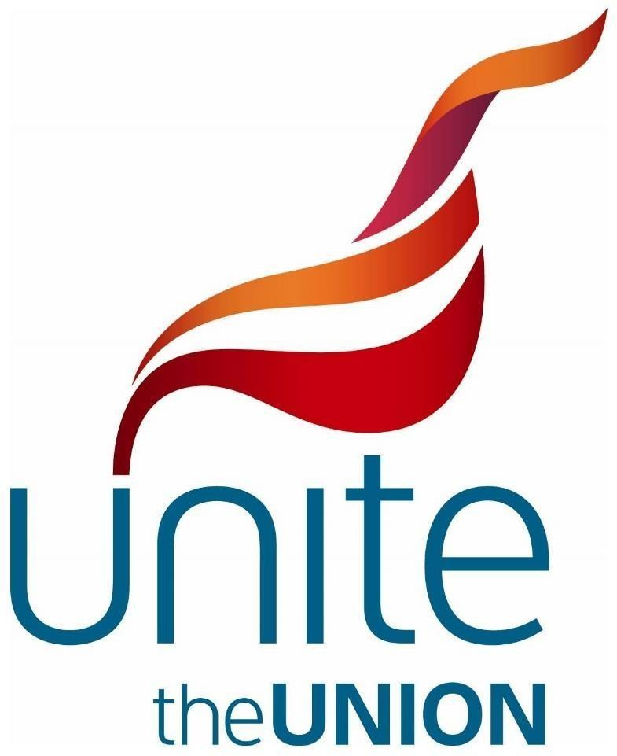

Birmingham Bin Strike CLP/Trades Council motion

July 2025

# This CLP/Trades Council notes:

* Birmingham bin workers are facing an £8000 per year pay cut.
* This is due to a litany of historic failures at Birmingham City Council (BCC) including the spend

£100m to repair the faulty Oracle computer system.

* During the strike, the government has drafted in the army to plan the rubbish clear up in Birmingham, used other council bin services from nearby councils to clear rubbish on Birmingham streets and used police to disrupt pickets, at great financial cost, estimated to be in excess of £8 million so far, excluding policing costs which at the end of May totalled almost £1m.
* Now, John Cotton, Angela Rayner and Max Caller & the commissioners are threatening to engage in Fire & Rehire as a brutal last resort to smash through damaging cuts to terms & conditions of Birmingham bin workers.

# This CLP/Trades Council believes:

* That Birmingham bin workers are right to use industrial action to pursue a fair and reasonable deal and to defend their pay and conditions of service.
* That Birmingham bin workers provide a vital and essential service to all Birmingham residents.
* That key Birmingham bin worker health and safety roles benefit all Birmingham residents.
* That the precedent of deleting and downgrading roles presents a risk to not only all BCC employees, but at other Local Authorities across the country.
* That watering down of the Employment Rights bill to allow an exemption for councils under intervention to use Fire & Rehire is not something a Labour government should be legislating for but should be honouring its manifesto to ban Fire & Rehire in its entirety.

# This CLP/Trades Council resolves:

* To circulate details of any solidarity action for Birmingham bin workers with all members
* To work with members and trade unions to build solidarity action with Birmingham bin strikers
* To circulate details of the Birmingham bin strikers’ strike fund to members and make a branch donation (Unite Solidarity Fund - 60-83-01 20502672 - payment reference 'BCC STRIKE DONATION’)
* To help build, organise and attend a joint union and community demonstrations whenever possible
* To send messages of support by mail/email/social media to Birmingham bin workers
* To commit our councillors and MP to support the Birmingham bin workers in resolving their dispute
* To arrange to receive a Birmingham bin worker speaker(s) at a future meeting
* To demand the immediate intervention of the government to bring a fair and reasonable settlement to end this dispute.
* To demand that Angela Rayner dismiss the proposals suggested by the Local Government Association (LGA) to water down the Employment Rights bill to allow for Fire & Rehire in local authorities and to instead reverse the 15 years’ worth of cuts in funding to put LA’s on a firmer financial footing.
* To call on the Labour government to use all its political capital to intervene and end the dispute.